

VCE General Mathematics Units 1&2

AT 1.3– OUTCOMES 1, 2 & 3
Week 11 Term 1 2023
You will have 75 minutes to complete this SAC.
Calculators and notes are permitted.
Linear Relations and Equations Test

Name: ____________________________________________

Circle teacher’s name: Ms Jabeen Ms Le Mr Rossignolo Ms Yang

Note: The grade or score for this task is only part of the internal assessment for this Unit. Your total School-assessed Coursework score may change as a result of statistical moderation.

Total : ____________ /60

Satisfactory Completion? S/N: ______
--------------------------------------------------------------------------------------------------
Assessment Criteria
Students should be able to:
- Define and explain key concepts and apply a range of related mathematical routines and procedures.
- Apply mathematical facts, concepts, models and techniques to investigate and analyse expended application problems in a range of contexts
- Use numerical, graphical and symbolic functionalities of technology to develop mathematical ideas, produce results and carry out analysis in situations requiring problem-solving, modelling or investigative techniques or approaches.

Instructions

A single bound reference and a CAS and scientific calculator permitted.
Answer all questions in the spaces provided.
Round final solutions to 2 decimal places unless specified otherwise.
In questions where more than one mark is available, appropriate working must be shown.
Multiple choice questions are worth one mark each.

Section A | Multiple Choice Questions | 14 marks

Circle the letter corresponding to the correct response.

1. If $s-10=54$, what is the value of $s$ ?

A. | $$4$$
B. | $$5.4$$
C. | $$44$$
D. | 64
E. | 540

2. What is the value of $I$, when $P=2000$, $R=0.04$and $T=3$ are substituted into the rule $I=PRT$?

A. | 2003.04
B. | 2003.4
C. | 24000
D. | 2400
E. | 240

3. Which of these equations has the solution $a=–2$ ?

A. | $$5+a=–7$$
B. | $$12- a=14$$
C. | $$a+8=10$$
D. | $$7a=14$$
E. | $$\frac{18}{–4a}=9$$

4. The cost of hiring a plumber is $150 plus $85 for every hour of work. If a plumber works for 3.5 hours on a particular job, how much will he earn?
A. | $$\$235$$
B. | $405
C. | $$\$447.50$$
D. | $$\$525$$
E. | $610

5. Which is correct if $y$ is made the subject of the equation $12x=14y-3$ ?
A. | $$y= \frac{6}{7}x+ \frac{3}{14}$$
B. | $$y= \frac{6}{7}x+ 3$$
C. | $$y= \frac{7}{6}x+ \frac{3}{14}$$
D. | $$y= \frac{6}{7}x- \frac{3}{14}$$
E. | $$y=– \frac{6}{7}x+ \frac{3}{14}$$

6. The solution to the simultaneous equations
$$3y-2x=8 \\ 2y+5x=-1$$
Is:
A. | $$x=-1, y=-2$$
B. | $$x=-1, y=2$$
C. | $$x=1, y=-2$$
D. | $$x=2, y=-1$$
E. | $$x=1, y=9$$

7. The slope of the line passing through (10, 9) and (6, -3) is:
A. | -3
B. | $$-\frac{1}{3}$$
C. | $$\frac{1}{3}$$
D. | 1.5
E. | 3

8. Players at a football club pay a fee of $130 each year. They also pay a fee of $12 for every game they play in that year. Last year, Maddie paid a total of $262 in fees at this football club. How many games did Maddie play last year?
A. | 10
B. | 11
C. | 12
D. | 13
E. | 14

9. An equilateral triangle has side lengths that are $x$ cm long. Each of the side lengths is increased by 3 cm to create a new triangle with a total perimeter of 25.8 cm. The value of $x$ is:
A. | 22.8
B. | 16.8
C. | 8.6
D. | 5.6
E. | 9.0

10. Which of the following is NOT a linear equation?
A. | $$y+8= 0$$
B. | $$A=πr^{2}$$
C. | $$C=2πr^{1}$$
D. | $$\frac{A}{l}= w$$
E. | $$7-3z=9$$

11. The cost $$C$, of using $K$ kilowatt hours of electricity can be calculated using the equation below: $C=52+0.15 ×K$. From this equation, it can be concluded that there is:

A. | no fixed charge and the electricity used is charged at $0.15 per kilowatt hour
B. | no fixed charge and the electricity used is charged at $52.00 per kilowatt hour
C. | a fixed charge of $0.15 and the electricity used is charged at $52.00 per kilowatt hour
D. | a fixed charge of $52.00 and the electricity used is charged at $0.15 per kilowatt hour
E. | a fixed charge of $52.00 and the electricity used is charged at $15.00 per kilowatt hour

12. A phone company charges a fixed, monthly line rental of $28 and $0.25 per call. Let $n$ be the number of calls that are made in a month. Let $C$ be the monthly phone bill, in dollars. The equation for the relationship between the monthly phone bill, in dollars, and the number of calls is:
A. | $$C=28+0.25n$$
B. | $$C=28n+0.25$$
C. | $$C=n+28.25$$
D. | $$C=28(n+0.25)$$
E. | $$C=0.25(n+28)$$

13. To raise funds, a club plans to sell lunches at a weekend market. The club will pay $190 to rent a stall. Each lunch will cost $12 to prepare and will be sold for $35. To make a profit of at least $1000, the minimum number of lunches that must be sold is:

A. | 22
B. | 35
C. | 36
D. | 51
E. | 52

14. The Blue Caps Cricket Club has different prices for its junior and senior subscriptions. The total cost for two junior subscriptions and one senior subscription is $225. The cost of a senior subscription is three times the cost of a junior subscription. The cost of a senior subscription is:
A. | $45
B. | $75
C. | $90
D. | $135
E. | $180

Section B | Short Answer Questions | 30 marks

Include working throughout.

- The sum of potential energy and kinetic energy is found using the formula: $E=mgh+{mv}^{2}$

(a) Calculate the value of $P$ if $m=$2, $v=2, h=10 and g=9.8$ |  | (b) Calculate the value of $m$ if $E=56,$$$g=9.8, h=10 and v=3$$
2 marks |  | 2 marks

- The circumference of a circle, $C$, is $C=2πr$, where $r$ is the radius. Calculate the circumference of a bike wheel with a radius of 27 cm. Answer correct to 2 decimal places.

2 marks

- Calculate the value of $y$ when$x=11$ using the equation $6y-3x=21$.

2 marks

- Suggested cooking times for roasting $x$ kilograms of meat are given by the table below:

Meat type | Cooking Time
Chicken (well done) | 45 mins/kg + 20 mins
Lamb (medium) | 55 mins/kg + 25 mins
Lamb (well done) | 65 mins/kg + 30 mins
Beef (medium) | 55 mins/kg + 20 mins
Beef (well done) | 65 min/kg + 30 mins

(a) How long, to the nearest minute, will it take to roast 2 kg of beef (medium)? |  | (b) At what time should you put a 4kg leg of lamb in the oven if you wish to serve it well done at 7 p.m?
2 marks |  | 2 marks

- A football club wishes to purchase pies from a catering company. The total cost of pies and delivery by the company is given by: $C=27+2.25x$, where C is the cost ($) and x is the number of pies.

(a) Using the equation provided, complete the table below:

$$x$$ | 40 | 45 | 50 | 55 | 60 | 65
$C$ ($)

2 marks

(b) If the total cost for the pies was $189, how many pies were purchased?

1 mark

(c) How much did each individual pie cost?

1 mark

(d) Explain what 27 represents in the equation.

1 mark

- Solve the following linear equations:

(a) $4+t=-6$ |  | (b) $\frac{2x-1}{3}=4$
1 mark |  | 2 marks

- Solve the following linear equations (show working):

(a) $2\left(n-3\right)+4\left(n+7\right)=10$ |  | (b) $5\left(p+4\right)=25+(7-p)$
2 marks |  | 2 marks

- In Australian football, a goal (g) is worth 6 points and a behind (b) is worth 1 point. The total number of points (P) is given by:
$$P=6g+b$$

(a) Rearrange the equation for $g$ |  | (b) Calculate the number of goals scored by a team, if they accumulated 70 points and 16 behinds.
1 mark |  | 2 marks

- Year 11 students want to run a social to fundraise for a local charity. The cost of hiring a photobooth and photographer is $990 and they are selling tickets for $15 per person. The profit, P, is found by subtracting the photography hire cost from the money raised selling tickets.

(a) Construct an expression for the profit, $P$, if $t$ is the number of tickets sold. |  | (b) The students counted a profit of $825. How many tickets did they sell?
1 mark |  | 2 marks

Section C | Extended Response Question(s) | 16 marks
Include working throughout.

Question 1 (4 marks)
Two sides of a triangle are equal represented by the length, $x.$ The remaining side is 7 cm shorter.

- Draw a diagram of the triangle, marking its dimensions in terms of $x.$

1 mark
- The perimeter of the triangle is 68 cm. Write an equation to represent this situation.
1 mark

- Solve the equation and hence state the lengths of each side of the triangle.
2 marks

Question 2 (8 marks)
A water charging system increases the amount people pay as the amount of water used increases. The charging system is modelled by
$$C=5+0.4x 0≤x<30 \\ C=-31+1.6x x≥30$$$C$ is the charge in dollars and x is the amount of water used in kilolitres (kL).
- Use the appropriate equation to determine the charge for using

(i) 20 kL |  | (ii) 30kL |  | (iii) 60kL
1 mark |  | 1 mark |  | 1 mark

- At what rate, cost per kL, is the cost increasing when you use
(i) less than 30kL |  | (ii) more than 30kL
1 mark |  | 1 mark

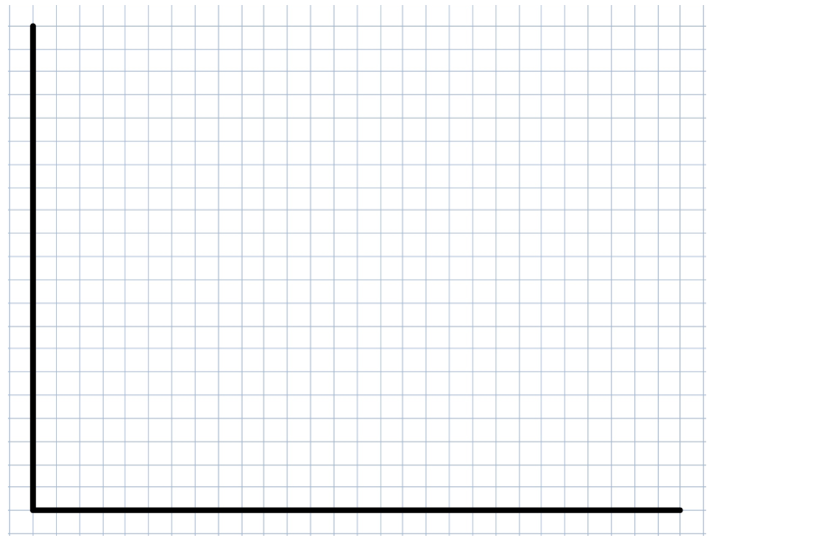
- Use the equations to construct a piecewise graph for $0≤x≤50$
3 marks

Question 3 (4 marks)
The Melbourne Museum charges $10 for children and $15 for adults.
One hundred and twenty-five people attended the Melbourne Museum within the first two hours of opening, an amount of $1325 was collected in ticket fees.
Write a set of equations to represent the number of tickets sold and the amount collected in ticket fees and determine how many adults, x, and children, y, attended the museum during this time period.
4 marks

END OF TEST

